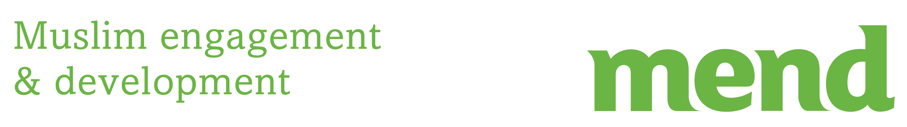

Date: xx/xx/2015

Dear XXXX,
Re : Hustings with Local Muslim Community
On XXX April, a cross-section of influential local Muslims, community leaders, businessman, women’s groups and more will be a hosting a hustings designed to cover issues which matter to local Muslims when it comes to electing our Parliamentary representative. The Hustings will be conducted by the local working group of MEND (Muslim engagement and development) a specialist Muslim organisation dedicated to tackling Islamophobia via advocacy in Westminster and grass roots community empowerment across the UK. MEND gave oral testimony in the Leveson Inquiry on press ethics, it sits on the CPS’ national hate crime sub-panel and works with police forces across the UK to reduce Islamophoic attacks. You can download MEND Muslim manifesto for the general election 2015 at www.mend.org,uk/muslim-manifesto as vital prep reading prior to the Hustings.
The details of the Hustings are as follows:
Venue
Time
Please kindly let me know if you are able to attend at your earliest convenience day. In the meantime, I enclose some information on MEND too.

Kind Regards

XXXX
MEND Preston Working Group
Volunteer
Enc.

