Islamophobia Khutbah

PART ONE: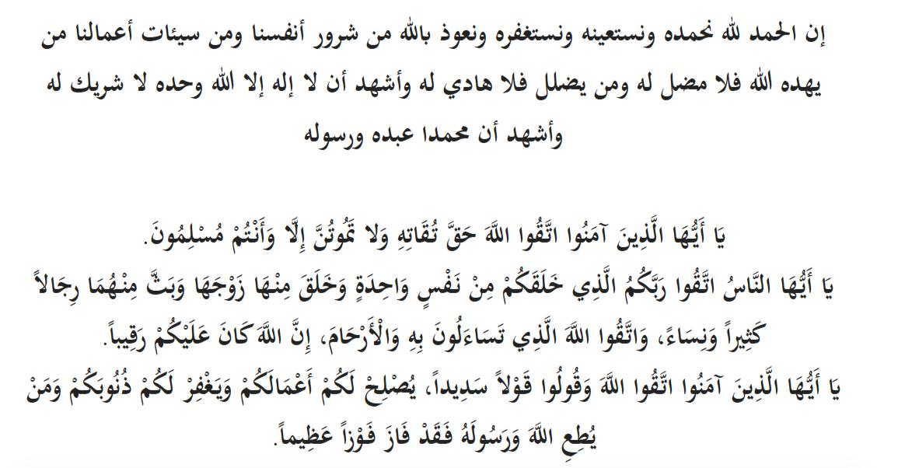

As the country continues to find itself in the grip of a pandemic, this week in our Khutbah, I want to focus on an issue which is a disease of a different kind. It is something which can and has affected most of us at some point in the past and is likely to also do so in the future.

One of the truly pressing issues of our time is that of the increasing Islamophobia the Muslim community faces here in the UK. We hear about it regularly, see it on our social media feeds and may have even been unfortunate to experience it ourselves – yet individually and collectively are we doing enough to tackle this problem?

Islamophobia manifests itself in many ways, whether it is ridiculing our religion, inciting hatred towards Islam and Muslims or in the worst cases, physical attacks on Muslims. But the worrying thing for us must be that these attacks seem to be on the rise and are becoming more common.

What is more concerning further still is how Islamophobia has become engrained and institutionalised within certain sections of the media and even the government. As an example, during the current COVID-19 pandemic, there has a been a disproportionate focus on Muslims in some of the reporting on Coronavirus. Regularly we saw pictures of Muslim women in hijab and niqab put next to headlines about Covid-19 spreading rapidly, and about social distancing measures not being followed etc.

And from the perspective of government, we have seen so many cases of MPs and senior figures blaming Muslims and making hurtful comments against Islam and Muslims. This is a deeply rooted problem which we must stand up against.

The Prophet (SAW) said in Sahih Muslim (2586):

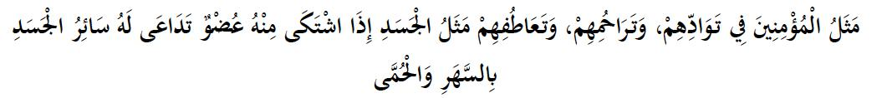

*“The believers, in their mutual mercy, love and compassion, are like a (single) body; if one part of it feels pain, the rest of the body will join it in staying awake and suffering fever.”*

This is a reminder that we should not just sit back and remain unaware of the issues our community face. Or turn a blind eye in the hope that it will not affect us directly. Or have the attitude that we only have to worry about ourselves and our individual Iman. If that is our attitude, then we are surely doomed to fail as a community.

There are many reasons as to why we should actively be at the forefront of tackling the issues our community faces. As we all know Islam is bigger than any one of us however noble our individual actions may be. We know that we are part of a larger Ummah and keeping to ourselves if anything is an un-Islamic quality. Our Deen encourages us to work towards the mutual benefit of all, and not to stick our heads in the sand, hoping others will step up on our behalf.

There’s a very interesting hadith, authentically narrated by Ibn Majah (304), that Sayyidina Abu Bakr al-Siddique (radhyAllahu ‘anhu) came to some of the Sahabah and recited this verse to them:

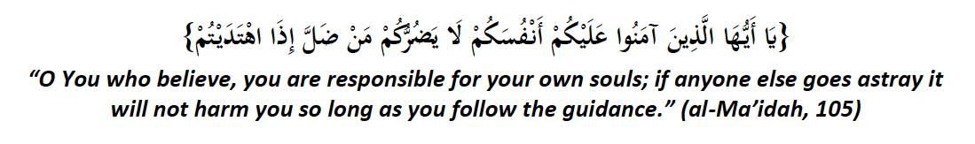

*Then he turned to them and said, “The people are taking this verse and not applying it properly.”*

What he wanted to say is that some of the Companions were understanding this verse in a very restricted sense, i.e. that if there are problems effecting the community, effecting others, well, as long as you look after yourself, then that’s all that matters. Which is completely wrong, because Sayyidina Abu Bakr then said:

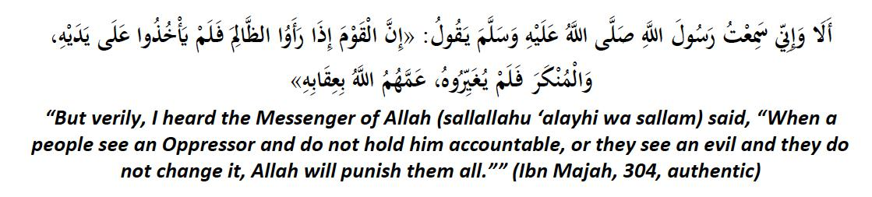

So, the ruling is clear. Yes, we concentrate on ourselves. And yes, we know that our enemies cannot harm us if we stay upon Divine Guidance. But when there is harm and evil and oppression and injustice in front of us, and when our brothers and sisters need our help, then we must ACT! Immediately!

The Prophet (sallallahu ‘alayhi wa sallam) said in Sahih Muslim:

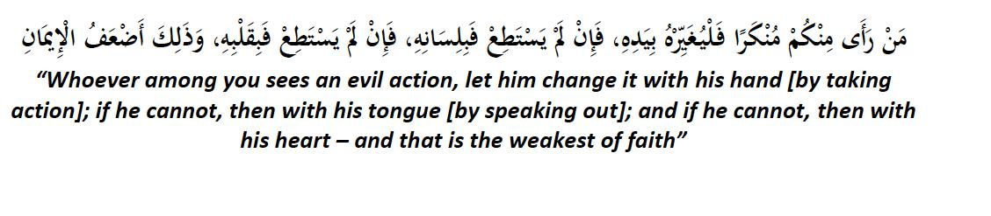

So, it does not matter what a person does, but we must do SOMETHING. Doing nothing is NOT an option.

And what you do is based on your ability, things which you really CAN do. No-one is going to ask you to do the impossible and heal the world in a week. But what you WILL be told is to come out of your comfort zone and work together to make sure that the threat of Islamophobia doesn’t reach a state where neighbours start murdering one another, such as what we saw in Bosnia, or even in the Central African Republic today.

These are not scare tactics. If we do not all do something to change the status quo, if we don’t get out there and create our own narrative as per the Book of Allah, then those who hate us will create that narrative for us!

Those who sacrifice their time, strategize, plan, protest, engage, all in the hope of doing what is right and forbidding wrong, are truly the best of people and what we should all aim to be:

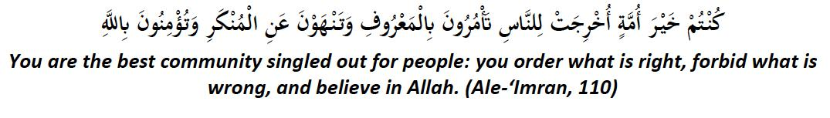

I pray that Allah makes us an Ummah that takes action and does not sit back. I pray that Allah makes us an Ummah that works to protect the honour of other believers and not forsake it. I pray that Allah does not burden us with a trial that which we cannot bear but strengthens us of those who enjoy the good and forbid the evil.

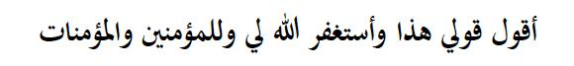

[End of First Khutbah]

PART TWO:

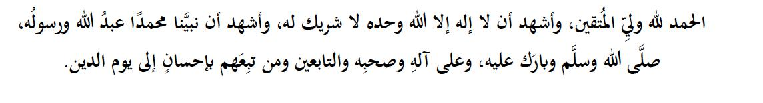

So, what CAN you do to fulfil your obligation of preventing evil, and working for the sake of your community when it comes to a problem like Islamophobia?

Here is a three-pronged plan:

Number 1. Educate yourself and other Muslims on hate crime in particular Islamophobia and encourage people to report every crime to the Police.

You MUST report these to the police. There are groups out there that have worked tremendously hard to get the police to record Islamophobia as a separate category of crime so that we can have accurate recording. But you may still wander why reporting is so crucial?

Because then we have the cold hard facts to show to the authorities and prove that there is a real quantifiable problem that fluctuates here and there and can be traced back to certain events, political statements, policy decisions, and other factors by which we can hold our leaders accountable.

So in summary call 999 in the case of an emergency or 101 in the case of a non-emergency in order to report an Islamophobic incident – be sure to ensure the police do record the incident as Islamophobic and not allow them to mistake it for another category of crime.

If you do not feel confident or comfortable calling the police directly then you can report it to MEND’s Islamophobia response unit. Visit www.mend.org.uk for details on how to do this.

Number 2. We need to initiate Public Awareness Campaign to help non-Muslims understand the impact of anti-Muslim prejudice and hate crime on Muslim communities.

We must disseminate better the fact that Islamophobia is a problem for society to tackle as a whole, not just Muslims. This is a blight on ALL our society and reflects negatively on all of us, and not just the criminals. Your non-Muslim friends, neighbours and colleagues can present a case or argue our side far more effectively than Muslims can, and it is a more impassioned appeal when they really FEEL the problem themselves. We must educate them.

Finally, Number 3. Getting involved - we want to get the message out there that until we fully engage as citizens of this country and realise our duties, we will not make progress on

stemming this form of hate crime.

This means we must comment, challenge, and even commend – yes, thank and appreciate - the media appropriately when they write a story about us in the news. We cannot be silent voices on the side and remain ignored. This means we must also engage our politicians whether councillors or MPs on taking a robust stand against Islamophobia.

Practically, we must as Muslims not only portray our Deen correctly and positively but reach out to non-Muslims by organising informal meetings with friends and family, and then more formal open days and events.

Dear elders, respected brothers, and sisters:

Ibadah can take shape in many forms. We have our Salah, our Zakah our Hajj and our Sadaqah. These are all forms of Ibadah we as a community understand the importance of well. But what is also vitally important is the work of defending the Deen of Allah, defending the honour of the believers, and helping to establish the worship of Allah on this earth. We would be incorrect in our understanding to think that somehow this work is lesser as a form of worship.

Tell that to the Hijabi sister getting her hijab pulled on the streets. Or the brother rejected at his job-interview because of his beard. Or to the Muslims who have to read that we are the terrorist and extremists and the enemy within.

No. This is blessed work and once we act and get busy, Allah will help us as well, as He promises:

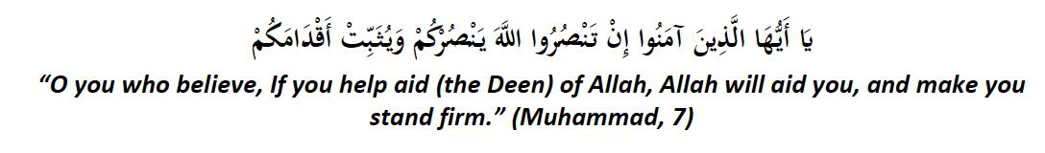

Please see the posters outside and get involved with the campaigns organised by MEND and others to ensure we make a difference.

Ya Allah, make us from the guided, guide others through us, and make us a reason that others are also guided.

Ya Allah, bless us all with tawfeeq, and give us success over those who wish to harm us and weaken us.

Ya Allah, strengthen this Deen, and its Believers, in our country here and in all parts of the world.